**1: Components of a Computer**

The five classic components of a computer are briefly described below. Each component is discussed in more detail in its own section. The operation of the processor is best understood in terms of these components.

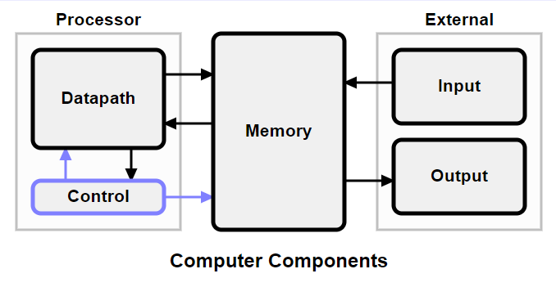

## CPU (Central Processing Unit)

CPU is considered as the brain of the computer. CPU performs all types of data processing operations. It stores data, intermediate results, and instructions (program). It controls the operation of all parts of the computer.

CPU itself has the following three components −

* ALU (Arithmetic Logic Unit)
* Memory Unit
* Control Unit

**Datapath**

The datapath manipulates the data coming through the processor. It also provides a small amount of temporary data storage.

The datapath consists of the following components.

programmable registers - small units of data storage that are directly visible to assembly language programmers. They can be used like simple variables in a high-level program.

the program counter (PC) - holds the address for fetching instructions.

multiplexers have control inputs coming from control. They are used for routing data through the datapath.

processing elements - compute new data values from old data values. In simple processors the major processing elements are grouped into an Arithmetic-Logic Unit (ALU).

special-purpose registers - hold data that is needed for processor operation but is not directly visible to assembly language programmers.

**Control -** generates control signals that direct the operation of memory and the datapath.

Control generates control signals that direct the operation of memory and the datapath. The control signals do the following.

* Tell memory to send or receive data.
* Tell the ALU what operation to perform.
* Route data between different parts of the datapath.

**Memory** - holds instructions and most of the data for currently executing programs.

The rest of the data is held in programmable registers, which can only hold a limited amount of data.

**Input** - external devices such as keyboards, mice, disks, and networks that provide input to the processor.

Input is data coming into the processor from external input devices such as keyboards, mice, disks, and networks.

In modern processors, this data is placed in memory before entering the processor. Input handling is largely under the control of operating system software.

**Output** - external devices such as displays, printers, disks, and networks that receive data from the processor.

Output is data going from the processor to external output devices such as displays, printers, disks, and networks.

In modern processors, this data is placed in memory before leaving the processor. Output handling is largely under the control of operating system software.

**2: Explain I/O Buses**

The *processor*, *main memory*, and *I/O devices* can be interconnected through common data communication lines which are termed as *common bus*.   
  
The primary function of a common bus is to provide a communication path between the devices for the transfer of data. The bus includes the control lines needed to support interrupts and arbitration.   
  
           The bus lines used for transferring data may be grouped into three categories:

* + - data,
    - address
    - control lines.

A single https://nptel.ac.in/courses/106103068/module07_io_devices/lect_01/equn/equn1.gif line is used to indicate Read or Write operation. When several sizes are possible like byte, word, or long word, control signals are required to indicate the size of data.

The bus control signal also carry timing information to specify the times at which the processor and the I/O devices may place data on the bus or receive data from the bus.

**3: Explain Motherboard Form Factor.**

## Types of Motherboard Form Factors

The motherboard form factor describes its **general shape**, the **type of case** and **power supply**it can use, and **its physical organization** (layout of the motherboard). Over time, in the computer industry, we have had a number of different motherboard form factors being developed.

## AT and Baby AT (Advanced Technology)

In the early days of the computer, the AT and baby AT form factors were the most common motherboard form factors. These two variants differ primarily in width: the older full AT board is 12" wide. It is an obsolete motherboard form factor only found in older machines, 386 class or earlier.

One of the major problems with the width of this board (aside from limiting its use in smaller cases) is that a good percentage of the board "overlaps" with the drive bays. This makes installation, troubleshooting and upgrading more difficult.

A Baby AT motherboard is 8.5" wide and 13" long. The reduced width means much less overlap in most cases with the drive bays, although there usually is still some overlap at the front of the case.

**Baby AT** motherboards are distinguished by their shape, and usually by the presence of a single, [**full-sized keyboard connector**](https://turbofuture.com/computers/Pc-ports) soldered onto the board. The serial and parallel port connectors are almost always attached using cables (ribbons) that go between the physical connectors mounted on the case, and pin "headers" located on the motherboard. Most of the boards use AT power supplies and the system units tend to be tower casing.

## AT Motherboard

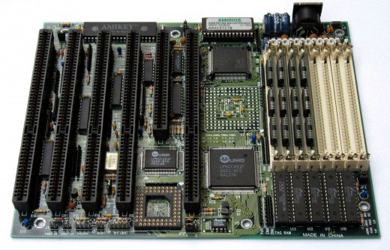

*AT motherboard. Note: at the top right hand corner of the board, we have the AT keyboard port* | Source

## Advantages of the Baby AT Motherboard Design

1. The size of 8.5” by 10” makes it easier to design smaller desktop PCs
2. Most of the board is easily accessible for upgrades and expansion

**Disadvantages of the Baby AT design**

1. CPU location- with the processor and heat sink in place, it is difficult to fit a long expansion card into one of the expansion slots. This is the main problem encountered with the AT-style motherboard-the CPU can get in the way of the expansion cards.
2. Motherboard mounting - some system cases are not drilled or punched to support all the mounting holes on a Baby AT motherboard. Therefore, the front edge of the system board tends to be left unsupported and over time this edge can warp (bend) leading to loose components and expansion cards causing intermittent problems.

## ATX and Mini ATX Motherboard Form Factors

### ****Full-ATX –****(12" wide x 9.6" deep) / ****Mini-ATX –****(11.2" wide x 8.2" deep****)****.

The ATX, Created by Intel in 1995, was developed as an evolution of the Baby AT form factor and was defined to address four areas of improvement:-

* Enhanced ease of use
* Better support for current and future I/O
* Better support for current and future processor technology, and
* Reduced total system cost.

The ATX is basically a Baby AT rotated 90 degrees and providing a new mounting configuration for the power supply. The processor is relocated away from the expansion slots, (unlike Baby AT) allowing them to hold full-length add-in cards.

The longer side of the board is used to host more onboard I/O ports. The ATX power supply, rather than blowing air out of the chassis, as in most Baby AT platforms, provides air-flow through the chassis and across the processor.

## ATX Motherboard

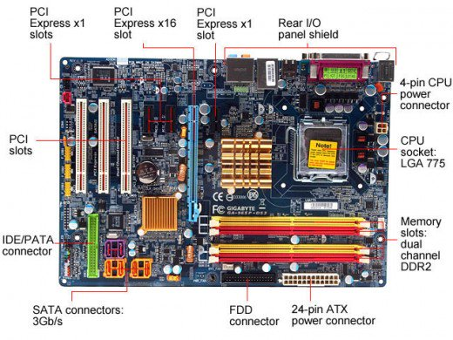

*ATX-Motherboard*

## Some Improvements of the ATX Motherboard Form Factor

* **Integrated I/O Port Connectors:** Baby AT motherboards use headers which stick up from the board, and a cable that goes from them to the physical serial and parallel port connectors mounted on to the case. The ATX has these connectors soldered directly onto the motherboard.
* **Integrated PS/2 Mouse Connector:** ATX motherboards have the PS/2 port built into the motherboard.
* **Reduced Drive Bay Interference:** Since the board is essentially "rotated" 90 degrees from the baby AT style, there is much less "overlap" between where the board is and where the drives are thus making it easy to access the board, and fewer cooling problems.
* **Reduced Expansion Card Interference:**The processor socket/slot and memory sockets are moved from the front of the board to the back right side, near the power supply. This eliminates the clearance problem with baby AT style motherboards and allows full-length cards to be used in most (if not all) of the system bus slots.
* **Better Power Supply Connector:** The ATX motherboard uses a single 20-pin connector instead of the confusing pair of near-identical 6-pin connectors on the baby AT form factor.
* **"Soft Power" Support:** The ATX power supply is turned on and off using signaling from the motherboard, not a physical toggle switch. This allows the PC to be turned on and off under software control, allowing much-improved power management.
* **3.3V Power Support:** The ATX style motherboard has support for 3.3V power from the ATX power supply.
* **Improved Design for Upgradability:** In part, because it is the newest design, the ATX is the choice "for the future". More than that, its design makes upgrading easier because of more efficient access to the components on the motherboard.

## MicroATX Motherboard Form Factor

This form factor was developed as**a natural evolution of the ATX form factor** to address new market trends and PC technologies. MicroATX supports:

* Current processor technologies
* The transition to newer processor technologies
* AGP high-performance graphics solutions
* Smaller motherboard size
* Smaller power supply form factor

**Flex ATX**

This is a subset of MicroATX developed by Intel in 1999. It allows more flexible motherboard design, component positioning, and shape. Can be smaller than regular microATX.

* Supports current socketed processor technologies
* Smaller motherboard size
* ATX 2.03 I/O panel
* Same mounting holes as microATX
* Socket only processors to keep the size small

## LPX and Mini LPX (Low Profile Casing eXtended)

**Note:** These Motherboard Form Factors are obsolete.

The LPX motherboard form factors are designed to be used in small Slimline or "low profile" cases typically found on low profile desktop systems. The primary design goal behind the LPX form factor is reducing space usage (and cost).

The most distinguishing feature is the riser card that is used to hold expansion slots. The riser card of the LPX motherboard form factor is situated at the center of the motherboard. Expansion cards plug into the riser card; usually, a maximum of just three. This means that the expansion cards are parallel to the plane of the motherboard.

This allows the height of the case to be greatly reduced since the height of the expansion cards is the main reason full-sized desktop cases are as tall as they are. The problem is that you are limited to only two or three expansion slots!

While the LPX form factor can be used by a manufacturer to save money and space in the construction of a custom product, these systems suffer from non-standardization, poor expandability, poor upgradability, poor cooling and difficulty of use for the do-it-yourself.

## LPX Motherboard Form Factor

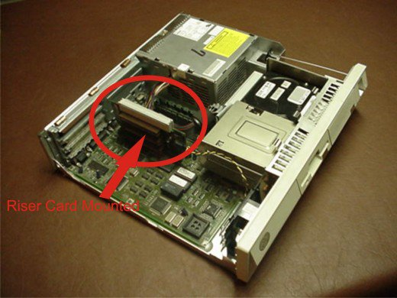

*LPX Motherboard with a riser card mounted.* | Source

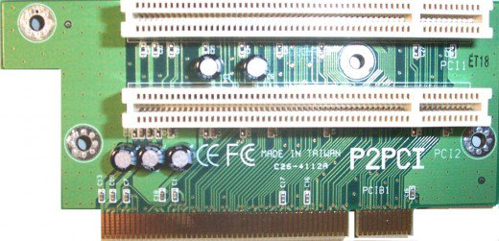

*The riser card, where adapter cards are connected*

## NLX (New Low Profile eXtended) Form Factor

**Note**: This motherboard form factor is also obsolete.

The need for a modern, small motherboard standard led to the development of the new NLX form factor. In many ways, NLX is similar to LPX. Also like ATX, the NLX standard was developed by Intel Corporation in 1998.

NLX still uses the same general design as LPX, with a smaller motherboard and a riser card for expansion cards. The riser card is pushed to one extreme edge of the motherboard.

**NLX makes the following main changes:-**

* Revised design to support larger memory modules and modern DIMM memory packaging.
* Support for the newest processor technologies, including the new Pentium II using SEC packaging.
* Support for AGP video cards.
* Better thermal characteristics, to support modern CPUs that run hotter than old ones.
* More optimal location of CPU on the board to allow easier access and better cooling.
* More flexibility in how the motherboard can be set up and configured.
* Enhanced design features, such as the ability to mount the motherboard so it can slide in or out of the system case easily.
* Support for desktop and tower cases.

## NLX Motherboard Form Factor

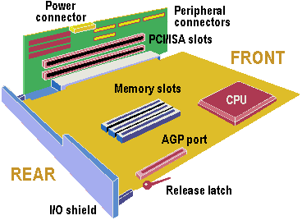

*An Illustration of NLX Motherboard Form Factor* | Source

5: Explain The System Resource

**Definition of: system resources**

**(1)** In a computer system, system resources are the components that provide its inherent capabilities and contribute to its overall performance. System memory, cache memory, hard disk space, IRQs and DMA channels are examples.

**(2)** In an operating system, system resources are internal tables and pointers set up to keep track of running applications. They may be limited by hardware resources, but are often as not arbitrary limitations within the software itself

**UNIT 2**

**1: Explaian Types Of Memory In Computer**

Types of computer memory (RAM and ROM)

Memory is the most essential element of a computing system because without it computer can’t perform simple tasks. Computer memory is of two basic type – Primary memory / Volatile memory and Secondary memory / non-volatile memory. Random Access Memory (RAM) is volatile memory and Read Only Memory (ROM) is non-volatile memory.

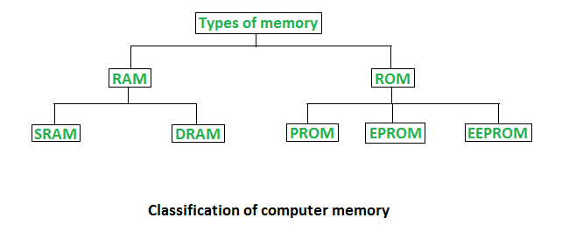

1. Random Access Memory (RAM) –

It is also called as read write memory or the main memory or the primary memory.

The programs and data that the CPU requires during execution of a program are stored in this memory.

It is a volatile memory as the data loses when the power is turned off.

RAM is further classified into two types- SRAM (Static Random Access Memory) and DRAM (Dynamic Random Access Memory). 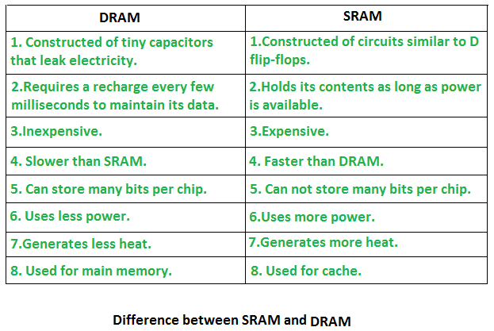

2. Read Only Memory (ROM) –

Stores crucial information essential to operate the system, like the program essential to boot the computer.

It is not volatile.

Always retains its data.

Used in embedded systems or where the programming needs no change.

Used in calculators and peripheral devices.

ROM is further classified into 4 types- ROM, PROM, EPROM, and EEPROM.

Types of Read Only Memory (ROM) –

PROM (Programmable read-only memory) – It can be programmed by user. Once programmed, the data and instructions in it cannot be changed.

EPROM (Erasable Programmable read only memory) – It can be reprogrammed. To erase data from it, expose it to ultra violet light. To reprogram it, erase all the previous data.

EEPROM (Electrically erasable programmable read only memory) – The data can be erased by applying electric field, no need of ultra violet light. We can erase only portions of the chip.

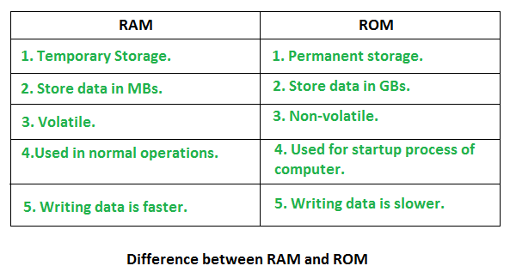

## 3: Explaine About Power Protection System.

## [Computer Power Protection](https://www.ifixit.com/Wiki/Computer_Power_Protection#Section_Computer_Power_Protection)

Even the best power supply is helpless without a source of reliable, steady AC power. Simply plugging your system into a wall receptacle and hoping for the best is a sure road to disaster, sooner or later. Before we smartened up, we lost many hours' work to power failures, and more than one system to lightning damage. All of that was preventable, if only we'd installed proper power protection. There are two types of power protection.

## 

## 4: Explain About Mice And Joystick.

## Definition - What does *Joystick* mean?

A joystick is an input device that can be used for controlling the movement of the cursor or a pointer in a computer device. The pointer/cursor movement is controlled by maneuvering a lever on the joystick. The input device is mostly used for gaming applications and, sometimes, in graphics applications. A joystick also can be helpful as an input device for people with movement disabilities.

## explains *Joystick*

The joystick is mostly used when there is a need to perform a direct pointing or when a precise function is needed. There are different types of joysticks such as displacement joysticks, hand-operated joysticks, finger-operated joysticks, thumb/fingertip-operated joysticks, hand-operated isometric joysticks, etc.  
  
Similar to the mouse in movement and usage, joysticks also include buttons, sometimes known as triggers. The difference between the mouse and the joystick is largely based on the fact that the cursor/pointer continues the movement in the direction of the joystick unless it is kept upright, whereas the mouse prevents the cursor from further movement until it is moved.  
  
One of the noticeable advantages of the joystick is its ability to provide fast interactions, which are much needed in gaming applications. The joystick provides a much-needed gaming experience, which is better in quality compared to that provided by other input devices. It has a simple design and is easy to learn and use. It is often inexpensive.  
  
The joystick, however, is not as easy to handle when selecting options from a screen and is not a preferred input device in such cases. Some joysticks limit the direction of movement to forward, left, right and backward, and do not offer diagonal or lateral movements. Again, the joystick is not as robust as other input devices, and, sometimes, users find it difficult to control compared to other input devices such as the mouse.

# 5:Explain Types Of Keyboards

# 8 Different Types of Keyboards Available In The Market

# 

The keyboard is essential for a computer whether it is personal or laptop as it is used for navigation, process execution and so on. It is the best interface device that allows us to input the data. I would say that no PC is complete without a keyboard.

Some of my friends [**bought the external keyboard online**](https://www.mymagicfundas.com/buy-computer-parts-online/) with their laptop. Why because the inbuilt laptop keypad is delicate than a usual keyboard. So having the right keyboard is pretty essential for a computer user.

Here, through this post, I am presenting before you “different types of keyboards.” Are you cramping your forehead? Yes, there is a classification among [**computer keyboards**](http://www.hongkiat.com/blog/13-computer-keyboards-you-never-seen-before/).

This post will also help you to [**choose an apt keyboard for your requirements**](https://www.mymagicfundas.com/latest-released-computer-keyboards/). Read the entire post to figure it out.

## 8 Keyboard Types That You Should Know

Since the people need keyboards for various purposes, manufacturers have started to produce different types of keyboards for their computing wants. Here are some of the top keyboard types for your view.

[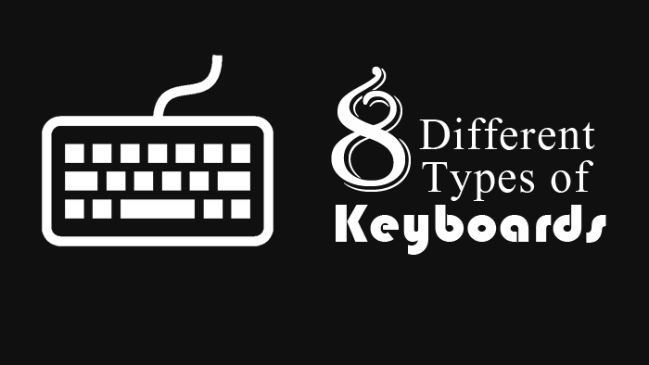](https://189852-562679-raikfcquaxqncofqfm.stackpathdns.com/wp-content/uploads/2015/05/keyboard-types.png)

## 1. Multimedia Keyboard

This is one of the most popular types of keyboard. Maybe you already guessed what it is by reading the name. Yes. It is a type of keyboard which includes multimedia buttons which help you to control your media only by a single tap.

Usually, a multimedia keyboard includes additional buttons or keys like play, pause, stop, next, previous, volume up, volume down, mute and a special button to launch the default music player in your PC. You can use these buttons for controlling video playback also.

What if you [**use the internet most of the time**](https://www.mymagicfundas.com/highest-internet-users/)? Is there any dedicated key for this purpose? Of course, there is. A browser launching button (usually with a home sign), an email button (opens your default email client like outlook), refresh, back and forward keys.

It is not over. Everyone opens “My Computer” many times daily. You may also use a calculator. A standard Multimedia keyboard contains these buttons also.

## 2. Mechanical keyboard

This is somewhat a primitive type of keyboard but preferred by many. The mechanical keyboard uses real physical buttons below each key. When you press a key, the button pushes down. Then there occurs the completion of an electric circuit. Hence, an electric signal is sent to the PC, and you see the desired result on the monitor.

That’s how a mechanical keyboard works. If you want to get the real feel of using a keyboard, grab one of this type now. Because it is louder and makes our fingers sense something rigid. Some mechanical keyboards come in an [**ergonomic design**](http://ergonomictrends.com/best-ergonomic-mechanical-keyboards/) that is more comfortable to type for a long time.

If you want your keyboard to be silent, skip this and see the next type. It may disappoint your expectations. Mechanical keyboards are usually more substantial than other types of keyboards. But it is proven to be long-lasting. The interesting fact is the cheapness of this type.

## 3. Wireless Keyboard

As the name suggests, it lacks a tail (I mean wire). It makes use of Radio Frequency, Bluetooth or Infra Red technology.

Portability is the vital feature of these computer keyboards. We can use it away from the parental device. If you have strong Wi- Fi connection, you can type on your PC by sitting even 50 meters far from it.

You can use this keyboard type with any of your gadgets like PC, mobile phone, [**tablet or laptop**](https://www.mymagicfundas.com/can-tablets-replace-laptops/) that supports wireless technology.

Among all, wireless keyboards are lightweight and small in size. Some wireless keyboards reduce the usage of a mouse by integrating a trackpad into it.

There must be two parts (apart from the keyboards) for this type of keyboard. A transmitter and a trans- receiver.

The transmitter is attached to the keyboard itself and the receiver, to the parent device.

Strokes from the keyboard are converted into radio waves and transmitted into the air using the transmitter. Trans- receiver attached to the PC or laptop senses these waves. Then, it gives the desired action.

## 4. Virtual Keyboard

It is not a physical keyboard but allows us to input keys. The virtual keyboard is not a hardware but can be a software or parts of the software.

This is the era of smartphones. So you must be accustomed to the keypad of your full- touch phone, right? It is an example of a virtual keyboard. We use our fingers to make inputs. There is no need to carry a physical object.

If you are a Windows OS user, you might have seen On Screen Keyboard. If you might not, then press Windows key+ R simultaneously to get Run box. After that, type “osk” on the field then hit enter. See, this is another example of a virtual keyboard.

Virtual keyboards appear for our needs and disappear after satisfying us. Or we can make it like that.

## 5. USB Keyboard

The invention of Universal Serial Bus aka USB was a massive leap in the history of computers. Today, we have USB keyboards, mouse, speakers, monitors and headphones also.

This type of keyboard uses the USB interface as a way of connecting with the host. Means, we get a wire with a USB stick at the end with this keyboard. Just insert it into the USB port of your computer. That’s all.

Earlier there were PS2 keyboards. PS2 was a particular type of port for mice and keyboards.

You may face a major issue if you use a USB keyboard. Our computer may not support USB keyboards at the time of booting. That means you can’t access and change BIOS (Basic Input/ Output System) settings.

But after installing suitable drivers of the keyboard, the issue may be solved.

## 6. Ergonomic Keyboard

These computer keyboards are built with considering ergonomics. If you own one of this type, it will be a great addition to your computer peripherals.

Usually, an ergonomic keyboard seems like a usually disabled keyboard. It resembles the English alphabet “V” in shape. Companies do it to make the two- handed users comfortable with it.

The most significant advantage is Ergonomic keyboard reduces muscle strain and the risk of Carpel Tunnel Syndrome. You may find it difficult to type with speed at the first use. But after some days of usage, it will dramatically increase your typing speed.

But the truth is, this type of keyboards are a little bit expensive, making no room for people with tight budget. There are many categories inside Ergonomic keyboard also. The aim is to increase the comfort of users.

## 7. QWERTY Keyboard

I think this is the one you are most familiar with. This type of keyboards needs no explanation. It is popular right from the age of typewriters.

QWERTY is a type of keyboard in which the keys are arranged in a specific order, not in the ABCD..order.

At the early days of typewriters, people find it hard to type with ABCD keyboards. It made use of strings underneath each key. Successive uses of consecutive keys made the strings entangle each other.

That was how QWERTY keyboards were born. Cristopher Latham Sholes found a solution for this. He placed nearly using letters as far as he could. So the problem was solved.

Even after, finding the latest technologies, we follow Sholes’ model of keyboards as a convention.

## 8. Gaming Keyboard

This is one of the best types of keyboards [**for hardcore gamers**](https://www.mymagicfundas.com/websites-play-free-online-video-games/). There are some specialties about Gaming keyboards.

You find some special keys on a Gaming Keyboard. Because they are built with bearing gamers in mind. We use W, S, D, A, arrow keys, and space a lot while gaming. In a gaming keyboard, these keys are highlighted and easily distinguishable even by a not- so- usual- computer user.

The biggest plus of this type of keyboards is its physical appearance. Most of the gaming keyboards have a stunning look. You will definitely fall in love with its design at the first look itself.

The manufacturers are very keen to insert graphics also. Mostly the graphic from any popular game.

This one also is a bit expensive like Ergonomic keyboards.

That’s all about different types of keyboards.

Now, let me tell you some tips to select the right keyboard for you.

### Tips to Select the Right Keyboard

Here are some guidelines to choose an exact keyboard for your necessity.

* Know your purpose of having a keyboard. You may have many uses. But bear the primary need in mind. You may be a crazy gamer, writer or a music lover.
* Choose a gaming keyboard if you are a gamer. Go for the multimedia keyboard if you are a music addict. If you [**want to be a better writer**](https://www.mymagicfundas.com/better-writer/), don’t choose these two. Both of them distract you away from work.
* Have an idea about your budget. This is very important. You can’t have a gaming keyboard with one dollar in hand. So make a range of money within what you are going to buy one. Like $50- 100.
* Make a list of five of your favorite keyboard manufacturing companies.
* Find four computer keyboards from them within your budget.
* See it with your purpose in mind. At this stage, you can eliminate something from the list.
* Compare the features of the keyboards. You can easily find 1- 2 is the best in terms of features and specifications.
* Select that one which lasts in your list.
* If you have 2 or 3 in the finalized list, ask your friends or relatives. This will surely end up in the right one.